LAB REPORT - EXPERIMENT 3

COEN 316 – Computer Architecture – Winter 2025
Section WC - X

Lab performed on : March 5th 2025
Report submitted on : March 19th 2025

Lab performed and report written by : Simon Guindon – 40058301

TA Instructor:
Umair Hussain

Introduction and Objective
This experiment’s objective is to introduce the experimenter to designing a next address unit. We will design the 32 bit version of it, as well as a sized down version so that the code would be physically testable on a Nexys A7 board.
Theory and Results
The usefulness of a next-address unit is its versatility to properly respond to a variety of opcodes. Depending on what is requested by the input, the system will properly respond to update the PC appropriately. For example, we can enter a 32 bits instruction to jump to a target address or to add/substract an offset to the PC when branching.
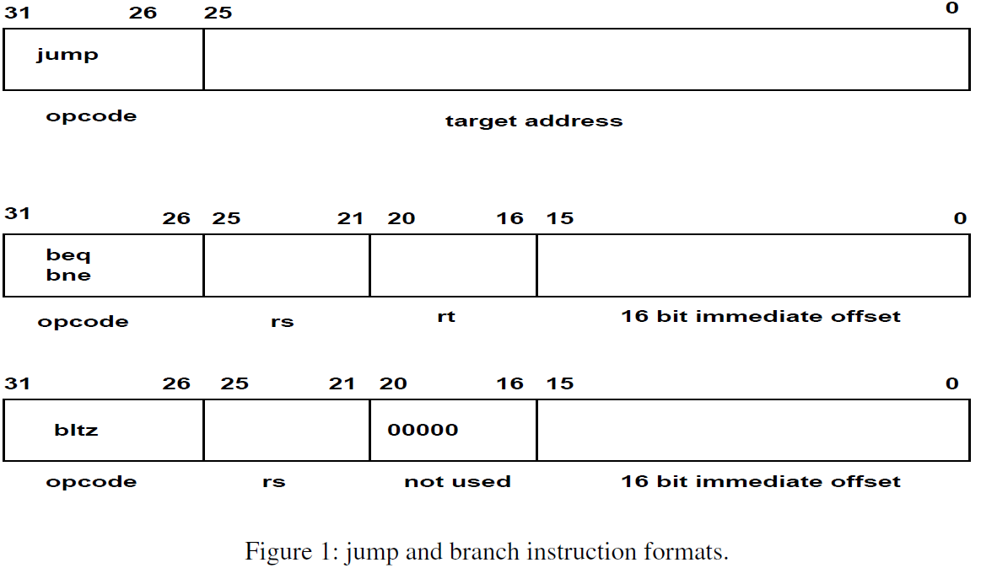

Results
Section 1.1 – Testing ModelSim’s output for next_address.vhd
For this section, we need to test the following combinations:
PC_sel = 00 & branch_type = 00 (adds + 1 to PC)
PC_sel = 00 & branch_type = 01 & rs == rt (adds offset + 1 to PC)
PC_sel = 00 & branch_type = 01 & rs =/= rt (adds + 1 to PC)
PC_sel = 00 & branch_type = 10 & rs == rt (adds + 1 to PC)
PC_sel = 00 & branch_type = 10 & rs =/= rt (adds offset + 1 to PC)
PC_sel = 00 & branch_type = 11 & rs < 0 (adds offset + 1 to PC)
PC_sel = 00 & branch_type = 11 & rs > 0 (adds + 1 to PC)
PC_sel = 01 (PC jumps to immediate value)
PC_sel = 10 (PC jumps to value stored in register rs)
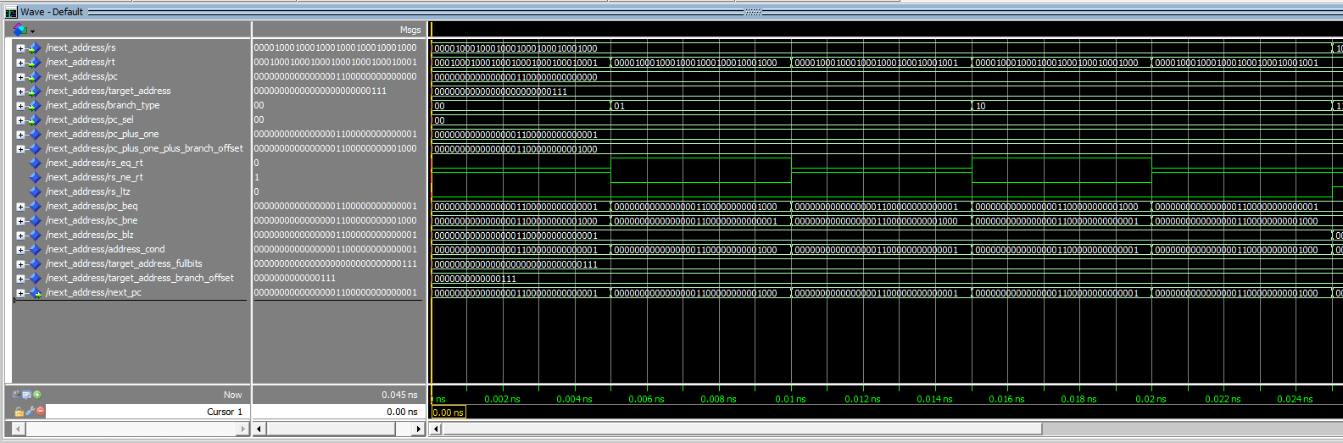
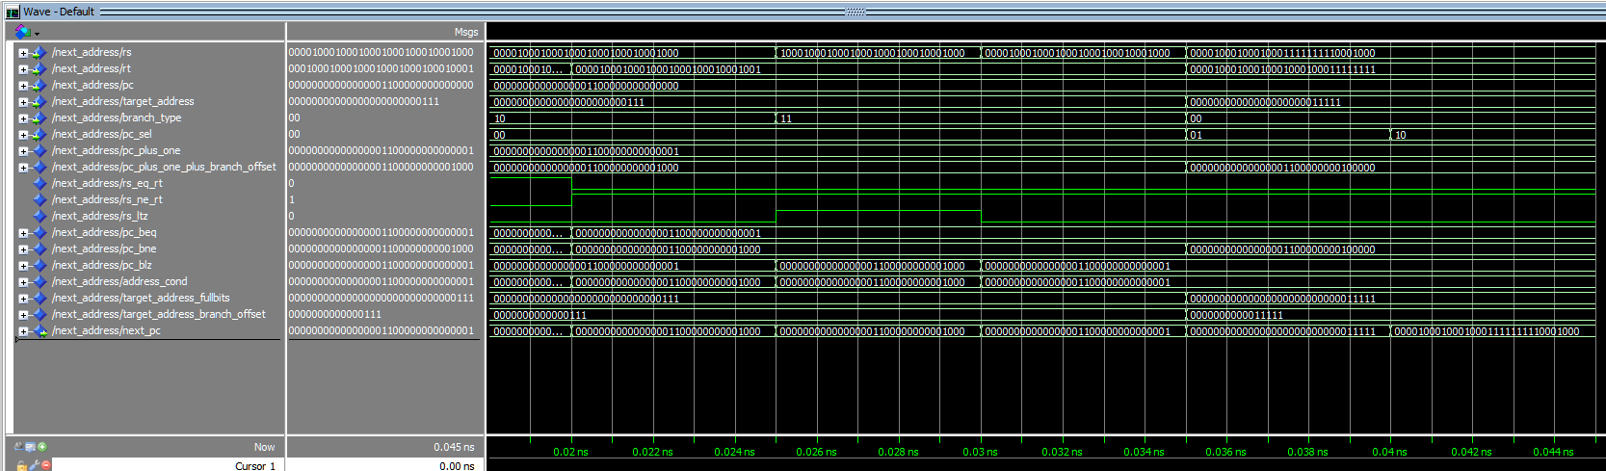
We obtain the following:
PC_sel = 00 & branch_type = 00 (adds + 1 to PC)
Expected: 00000000000000001100000000000001 since pc is 00000000000000001100000000000000
Obtained: 00000000000000001100000000000001
PC_sel = 00 & branch_type = 01 & rs == rt (adds offset + 1 to PC)
Expected: 00000000000000001100000000001000 since offset is 111 and we add 1
Obtained: 00000000000000001100000000001000
PC_sel = 00 & branch_type = 01 & rs =/= rt (adds + 1 to PC)
Expected: 00000000000000001100000000000001
Obtained: 00000000000000001100000000000001
PC_sel = 00 & branch_type = 10 & rs == rt (adds + 1 to PC)
Expected: 00000000000000001100000000000001
Obtained: 00000000000000001100000000000001
PC_sel = 00 & branch_type = 10 & rs =/= rt (adds offset + 1 to PC)
Expected: 00000000000000001100000000001000
Obtained: 00000000000000001100000000001000
PC_sel = 00 & branch_type = 11 & rs < 0 (adds offset + 1 to PC)
Expected: 00000000000000001100000000001000
Obtained: 00000000000000001100000000001000
PC_sel = 00 & branch_type = 11 & rs > 0 (adds + 1 to PC)
Expected: 00000000000000001100000000000001
Obtained: 00000000000000001100000000000001
PC_sel = 01 (PC jumps to immediate value)
Expected: 00000000000000000000000000011111
Obtained: 00000000000000000000000000011111
PC_sel = 10 (PC jumps to value stored in register rs)
Expected: 00001000100010001111111110001000 (value in rs)
Obtained: 00001000100010001111111110001000
Section 1.2 – Testing ModelSim’s output for nextadd_wrapper.vhd
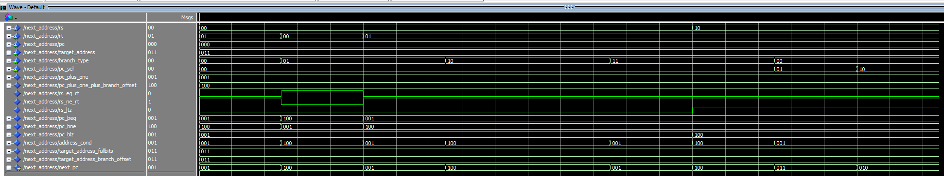

Similarly to above, we can see that the code works as intended, because the expected value matches what was obtained (thus reflects the results seen in the non-wrapper version). To avoid redundancy, the wrapper’s results will not be explicitly listed below.

Section 2.1 – VHDL source code for next_address.vhd
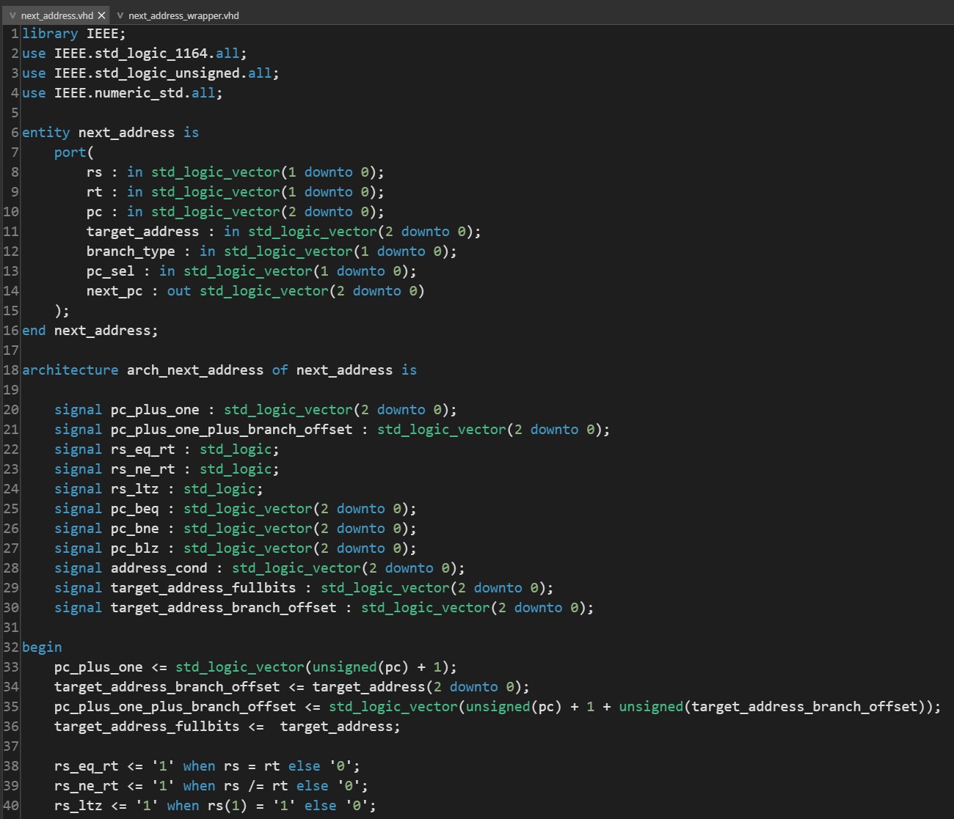
First, I declare internal signals to help with the wiring. I assign pc_plus_one to pc plus adding 1, take the first 16 bits of target_address to obtain the offset, add the offset and 1 to the pc for pc plus one plus offset and add 6 zeroes to target address to obtain a 32 bits value.
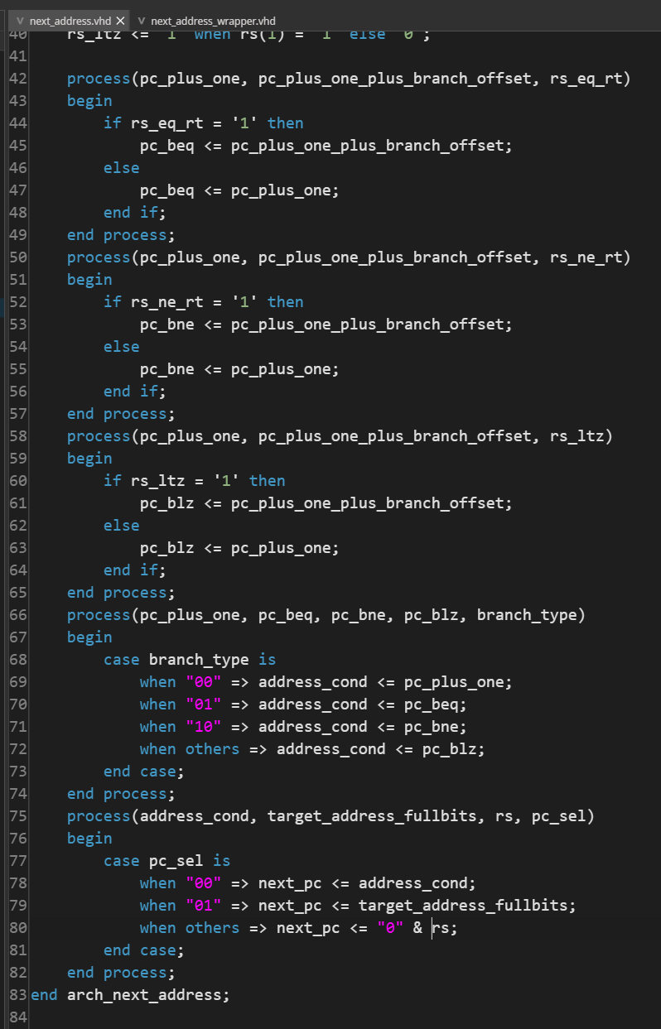
Section 2.2 – VHDL source code for next_address_wrapper.vhd
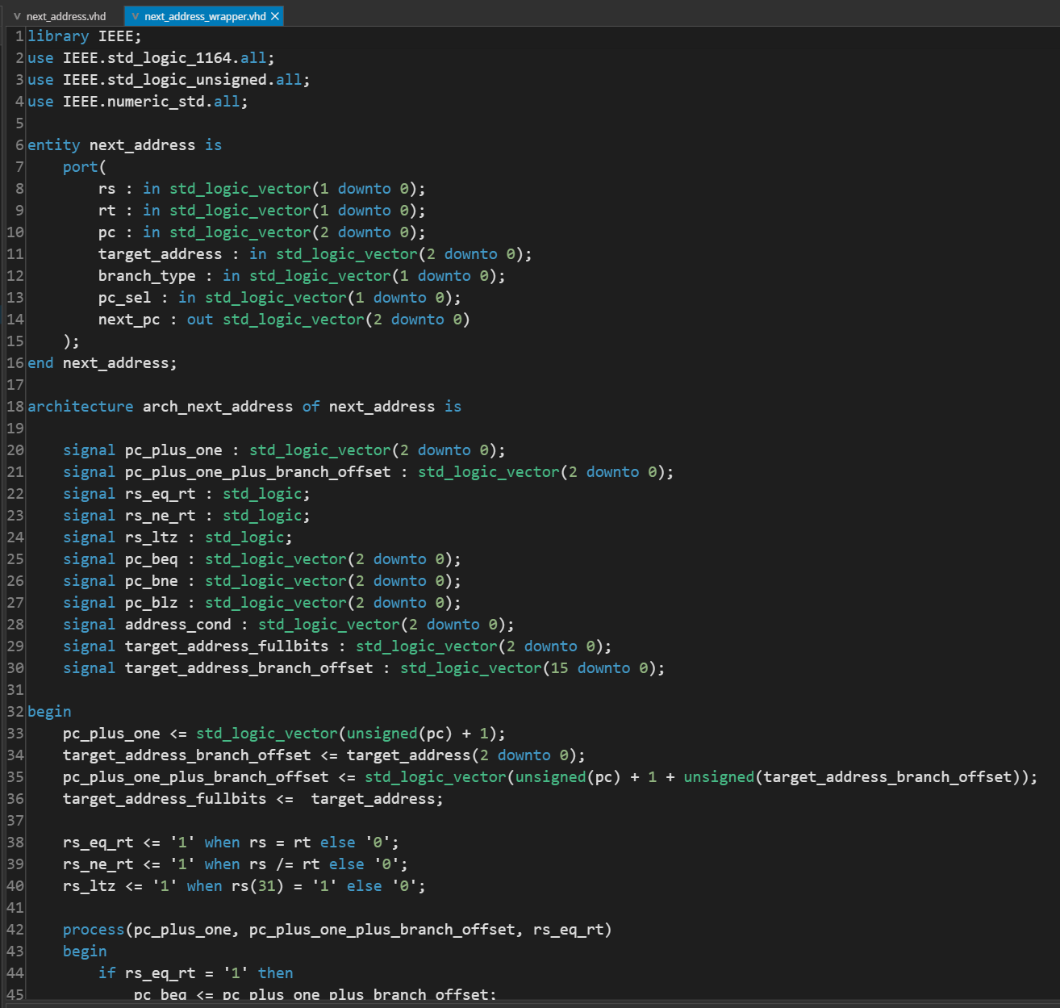

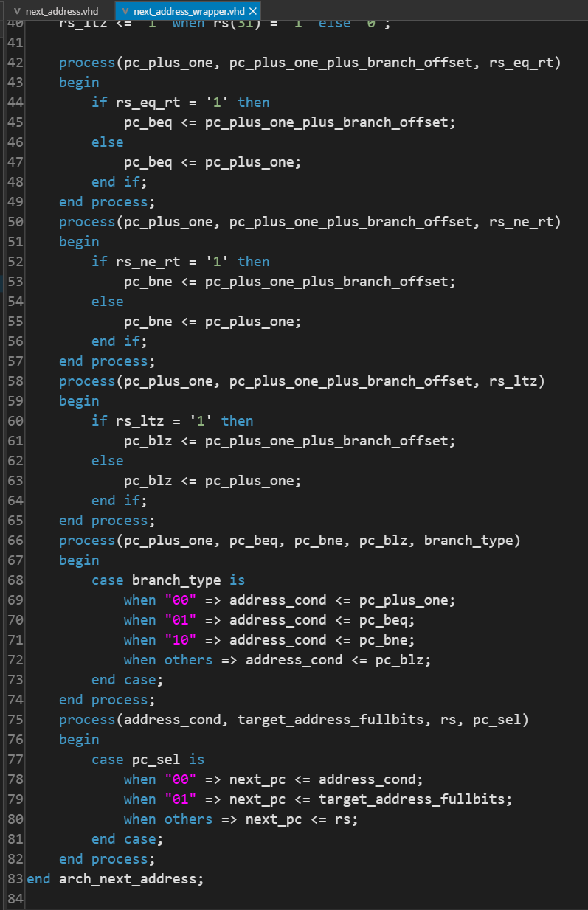
Section 3.1 – Do file for next_address.do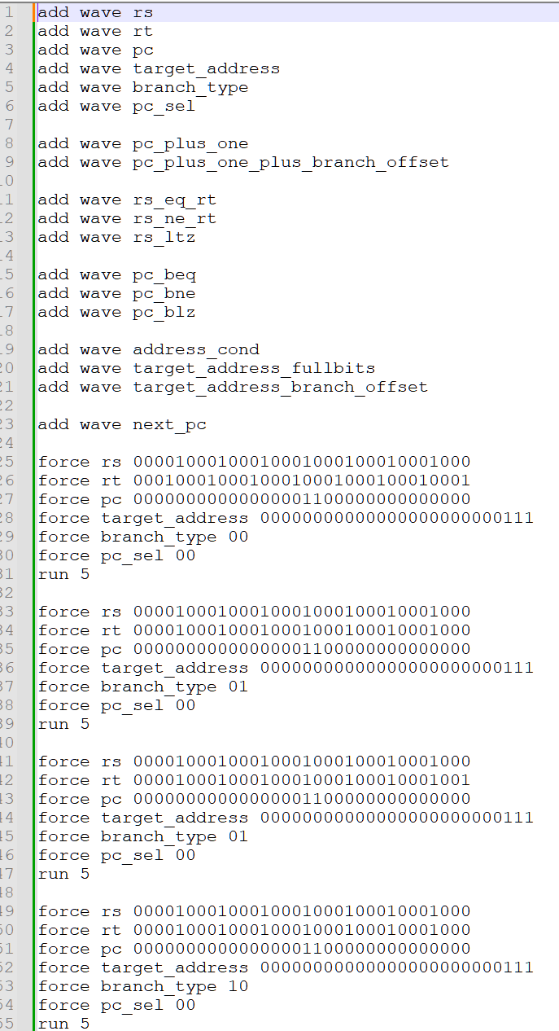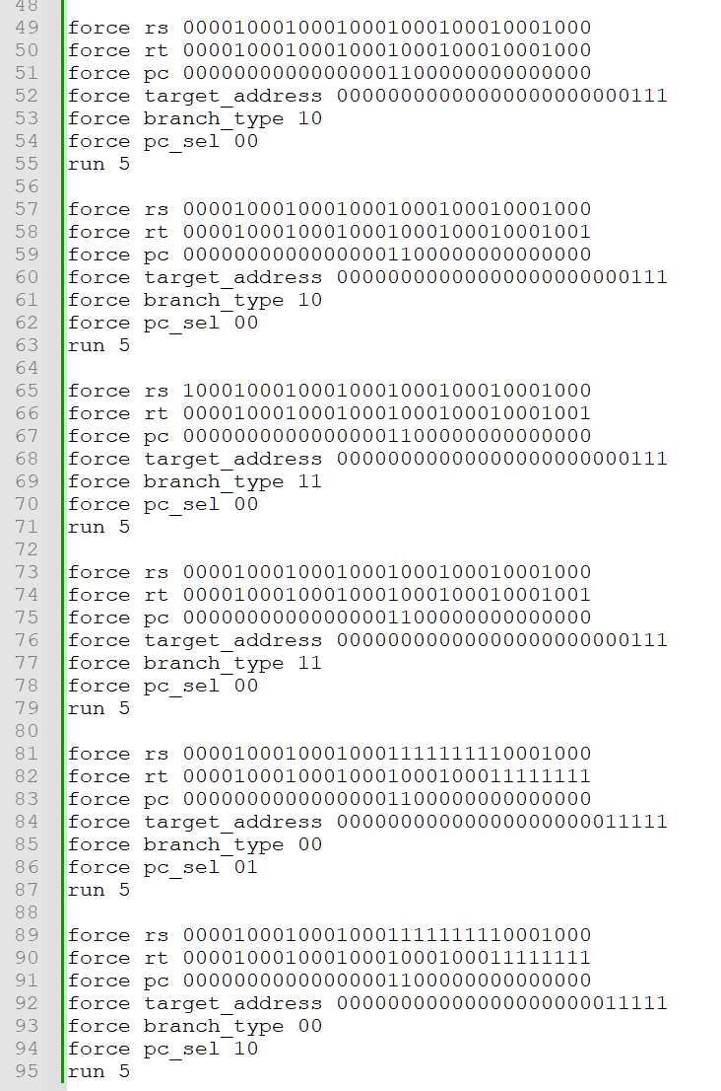
Section 3.2 – Do file for next_address_wrapper.do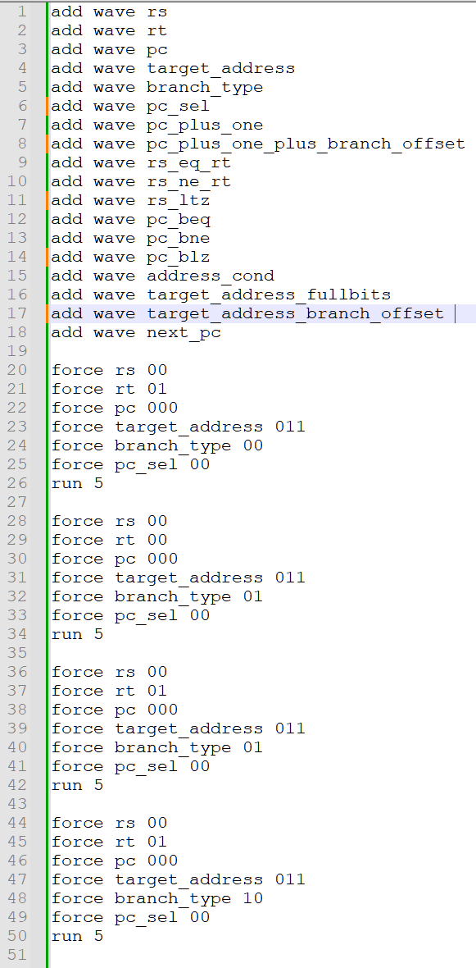
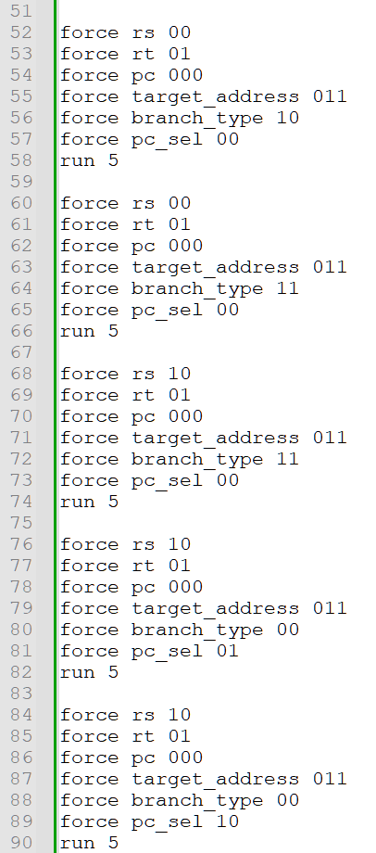
Section 3.3 – XDC file for next_address_wrapper.vhd (next_address_wrapper.xdc)
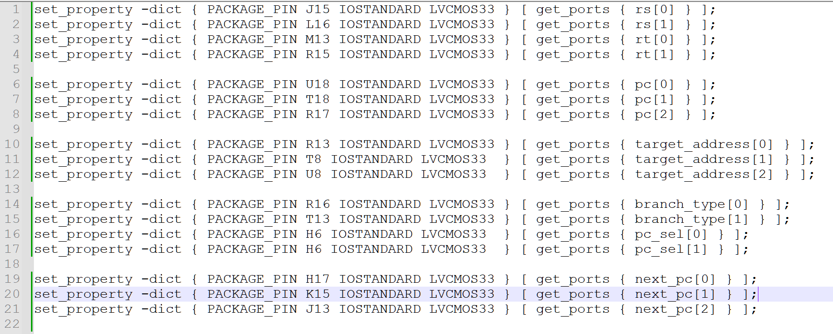
Conclusion
In conclusion we had our first experience building two versions of a next address logic unit, one with a full 32 bits input and a wrapper that can be presented on a Nexys A7 board. The results we obtained were in agreement with the theoretical output for the next address logic unit. Future labs will incorporate this logic unit into more complex systems.

;

